# Modeling

**1- Load libraries**

**2- Write a function to compute the Archie equation**

**3- Write a function to compute density porosity**

**4- Load the log data in the file 15_9-19.csv**

**5- Determine if there is any missing data**

**6- Plot a histogram for gamma ray**

**7- Calculate the density porosity for this well**

**8- Determine if you have all the data required to compute Archie water saturation**

**9- Calculate water saturation and analyze the quality of the data**

**10- Define a function to compute shale volume**

**11- Define a function to compute Simandoux water saturation**

**12- Compute Simandoux water saturation for the given well**

**13- Plot all the petrophysical data**

**14- Load data from file Data/ASCII/L0509WellData.csv**

**15- Produce a histogram of the gamma curve**

**16- Plot histograms for all curves**

**17- Plot a Density Porosity cross-plot**

**18- Normalize data to use in modeling - resistivity is usually not normalized. Load data from well**

**19- How many wells are there in the data dataframe**

**20- Describe the data for each well**

**21- Plot a distribution of GR for each well**

**22- Prepare data for normalization**

**23- Compute a normalization curve using the formula:**

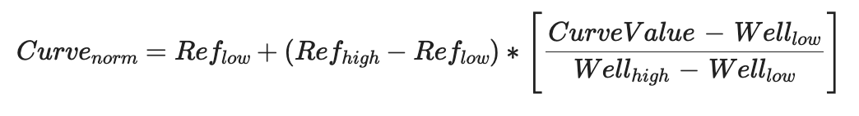

**24- Plot the normalized gamma curve**